*Amazon Sales Data Analysis* ***Wireframe Documentation***

Homepage

As per the problem statement, we have divided analysis into Five sections: -

1. 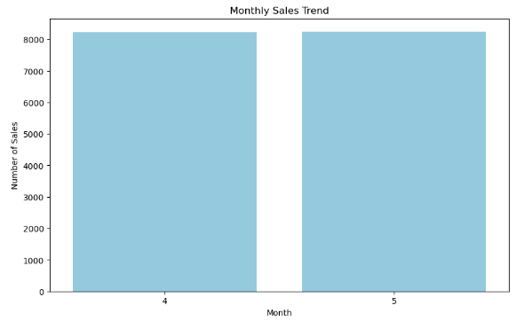**Monthly Sales Trend:**

In this section we designed our first dashboard and tried to interpret the followings

* **Number of Sales in a Month**

◼ **Yearly Sales Trend**

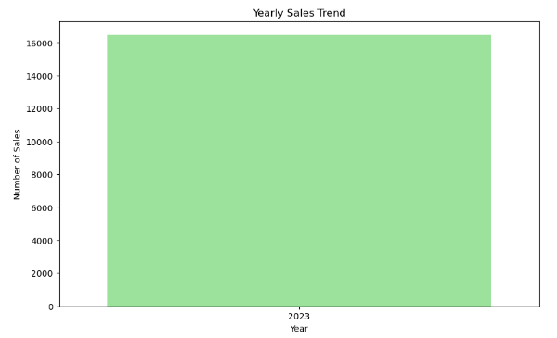

* Create a bar chart or line plot showing the total sales volume or revenue for each year.
* Use different colors or patterns to distinguish between years and emphasize growth or decline trends.
* Include annotations or labels to provide context, such as major product launches oreconomic downturns.

**◼ Yearly-Monthly Sales Trend**

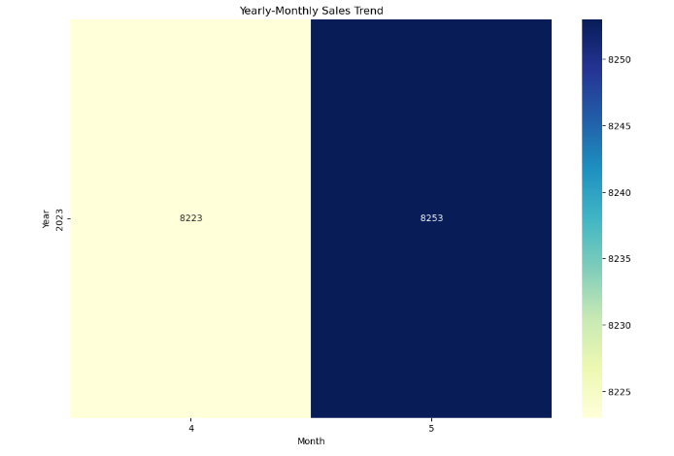

* Generate a heatmap or stacked area chart to visualize sales volume or revenue for each month across different years.
* Each row represents a year, and each column represents a month, with color intensity indicating sales performance.
* Use a color legend to interpret the heatmap and highlight variations in sales trends over time.

**Resolution time Distribution**

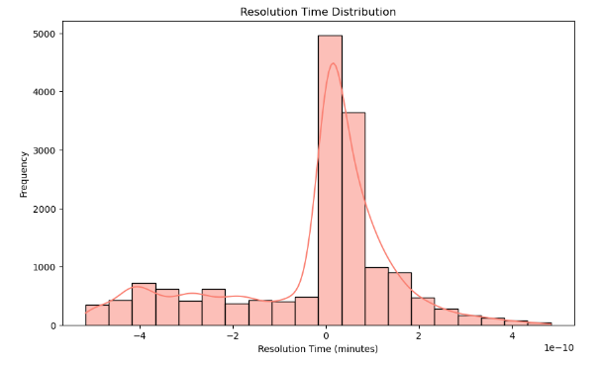

* Display the distribution of resolution times using a histogram or box plot.
* Bin the resolution times into intervals (e.g., 0-1 hour, 1-2 hours, 2-4 hours, etc.) on the x-axis.
* Plot the frequency or density of resolution times on the y-axis to show the distribution shape.
* Include summary statistics such as mean, median, and quartiles to describe the central tendency and variability of resolution times.

**◼ Requester wait Time Distribution**

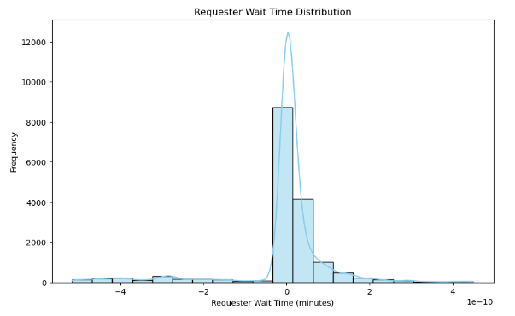

* Utilize a similar visualization approach as resolution time distribution to display the distribution of requester wait times.
* Bin the wait times into intervals and plot the frequency or density on the y-axis.
* Include summary statistics such as mean, median, and quartiles to describe the central tendency and variability of requester wait times.

**◼ Satisfaction Score Distribution**

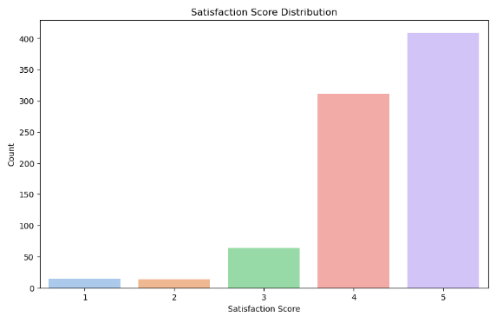

* Create a bar chart or pie chart to illustrate the distribution of satisfaction scores.
* Each bar or segment represents a satisfaction score category (e.g., Very Satisfied, Satisfied, Neutral, Dissatisfied, Very Dissatisfied).
* Include labels or tooltips to show the percentage of respondents in each satisfaction category.